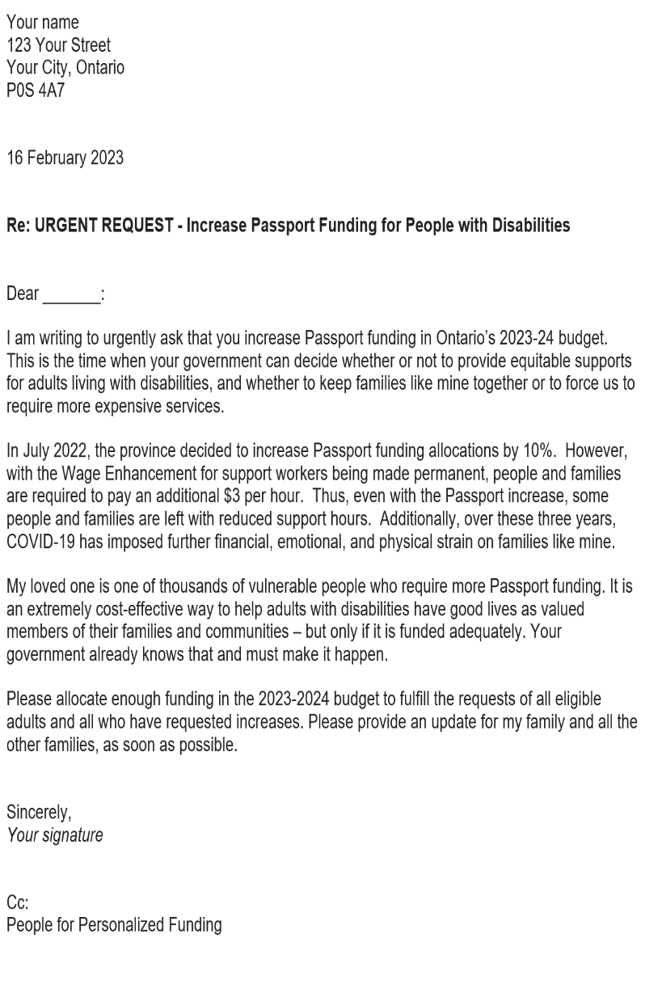
Add your own paragraphs here to explain how the pandemic has affected you, your loved ones, and/or your family.

Scenario A – if you are eligible but not yet receiving Passport funding, you might want to write about how long you’ve been waiting and the effect this has had on you and your family. How would receiving what you applied for improve your life and your family’s life?

Scenario B – if you already receive Passport funding, but it is inadequate, explain why more is needed. How many hours a day/week/year of a support worker’s time does your current allocation provide? How many hours a day/week/year remain where care is provided by family or loved ones? You might want to say whether you have applied for an increase, how long you’ve been waiting for that, what response you have received about either applying for or getting an increase, etc.

Scenario C – if you are juggling funding and support from a variety of government sources, you might want to say how the administration of all that affects your family, or mention gaps still remaining. How many hours a day/week/year of a support worker’s time do your combined current allocations provide? How many hours a day/week/year remain where care is provided by family or loved ones?

Scenario D – if you are satisfied with the Passport funding you or your loved one receive(s), tell them how that helps, and say why you want the same benefits for other families like yours.

Then, you can describe yourself or your loved one. Diagnostic labels are not necessary; you want the politician to get to know you better as individuals. Because Passport funding is allocated for supports and community participation, talk about why such help is needed. Describe how needs may have increased over the last 3 years because of COVID isolation and stress, communication challenges, health challenges, dynamics with others in the family, rising costs, financial distress, job changes, aging caregivers, etc.

Here is an example and guidance for a letter that people, families, and friends might want to write to the Ontario government – to show them how important it is to increase Passport funding for adults with disabilities.

Now is the time when the provincial government makes decisions about their budget for the next fiscal year, starting April 1st.

They need to know how important this is for you, your loved ones, and other people with disabilities.

You can decide whether you want to write to:
- Honourable Merilee Fullerton, MinisterMCCSS@ontario.ca
- Sylvia Jones MPP Sylvia.Jones@pc.ola.org
- The Honourable Doug Ford, Premier premier@ontario.ca and/or
- Your Member of Provincial Parliament (whose contact information can be found at https://www.ola.org/en/members )

Please use the template on the next page.
Insert your return address and update to the date you are mailing the letter.

Your name
123 Your Street
Your City, Ontario
P0S 4A7

16 February 2023

Re: URGENT REQUEST - Increase Passport Funding for People with Disabilities

Dear _______:

I am writing to urgently ask that you increase Passport funding in Ontario’s 2023-24 budget. This is the time when your government can decide whether or not to provide equitable supports for adults living with disabilities, and whether to keep families like mine together or to force us to require more expensive services.

In July 2022, the province decided to increase Passport funding allocations by 10%. However, with the Wage Enhancement for support workers being made permanent, people and families are required to pay an additional $3 per hour. Thus, even with the Passport increase, some people and families are left with reduced support hours. Additionally, over these three years, COVID-19 has imposed further financial, emotional, and physical strain on families like mine.

My loved one is one of thousands of vulnerable people who require more Passport funding. It is an extremely cost-effective way to help adults with disabilities have good lives as valued members of their families and communities – but only if it is funded adequately. Your government already knows that and must make it happen.

Please allocate enough funding in the 2023-2024 budget to fulfill the requests of all eligible adults and all who have requested increases. Please provide an update for my family and all the other families, as soon as possible.

Sincerely,
Your signature

Cc:
People for Personalized Funding

BEFORE YOU CLICK PRINT…

Use The Cc: section at the bottom of the letter to copy whoever you like and show their names here.

You may want to share with:
- other politicians (especially Opposition leaders, critics and MPPs),
- provincial associations,
- community allies,
- agency contacts,
- professionals, etc.

It is important that politicians know that other people have received copies of your letter, so they know the issues and want answers too.

As suggested, please consider copying your letter to People for Personalized Funding.

You can find out more and find resources at https://www.pfpf.ca

