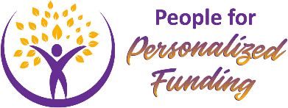
Formerly SSAHPC- Special Services at Home Passport Provincial Coalition!

March 12, 2021 URGENT ACTION IS NEEDED!

The Ontario government is keeping thousands of children with disabilities waiting for help on a lengthy Special Services at Home (SSAH) waitlist.

This pandemic has only highlighted how important adequate and timely support is needed so that children, youth and their families can thrive. It appears that 11,000 children may currently be on the waitlist and we expect that number to increase by thousands next year. Further analysis can be found at on our website.

If you are a family member, child or youth, or ally, contact your MPP and let them know
Ontario’s 2021-22 Budget must enhance SSAH funding so that the waiting list is eliminated and all children and youth are supported as soon as they become eligible.

HOW TO TAKE ACTION:
- Find out who your MPP. Click on this link to find your MPP’s contact information https://www.ola.org/en/members
- Send a message to your MPP and encourage others in your network as well. You can cut and paste the sample message below and send by email or use as a script for a phone call.

SAMPLE MESSAGE

Dear [MPP’S NAME],

I am writing as to express my concern that thousand of children and youth are languishing on long waiting lists for Special Services at Home (SSAH) – some waiting for years.

SSAH is an extremely important and cost-effective way to improve the lives of Ontario children and youth with disabilities. Families receive funding for workers or other supports so that young people can participate in and contribute to their communities.

We urge the government to ensure that children, youth and their families who live with disability receive immediate support. Ontario’s 2021-22 Budget must enhance SSAH funding so that the waiting list is eliminated and all children and youth are supported as soon as they become eligible.

[ADD YOUR OWN PERSONALIZED MESSAGE IF YOU WISH]
Sincerely,
[YOUR NAME]

